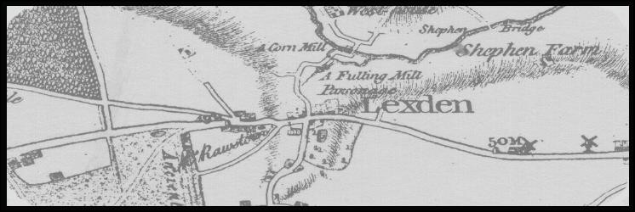
Lexden History Group

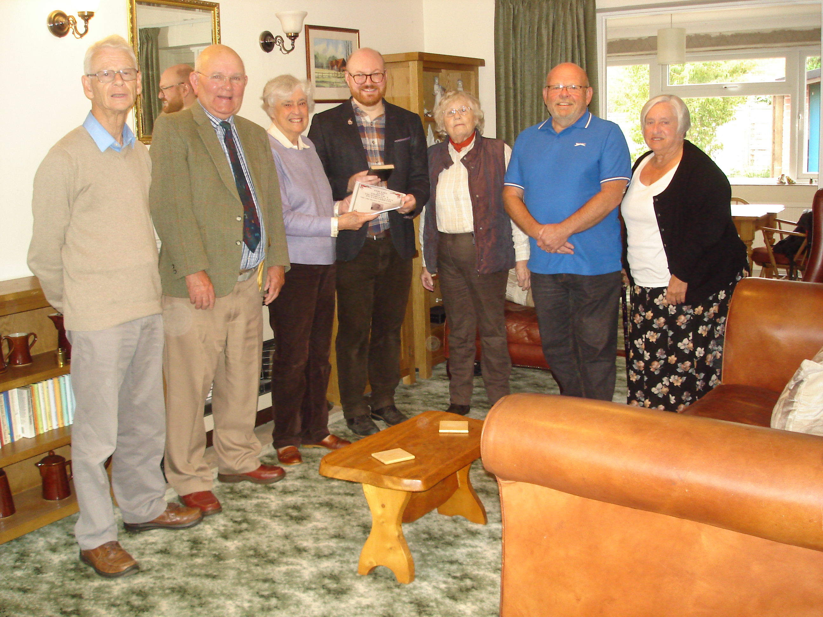

Lexden History Committee presenting Glynn Davis from Colchester and Ipswich Museums with the original 1885 Diary of Clarice Ord together with a copy of Liz White’s book.

- Tales from the Churchyard – Charlotte Dalby, The Crown Inn
- 1960 The Dine In and Dine Out
- Beware First Impressions
- The Royal Observer Corps at Lexden

Newsletter No 63 – December 2021

Website www.lexdenhistory.org.uk

Chairman’s Message Stan Kordys

1885 Diary The front page of the Newsletter, shows a splendid photograph of the official handover of the 1885 diary, along with a copy of the “Life and Times of a Victorian Lady in Colchester” by Liz White.

Sonia Lewis kindly hosted the handover to Mr Glynn Davis, Senior Collections and Learning Curator of Colchester Museums on the 8th October. Both items will now be safely stored in Colchester Museum Archives, allowing access for those interested, rather than the suggested storage place at Chelmsford Record Office (never!).

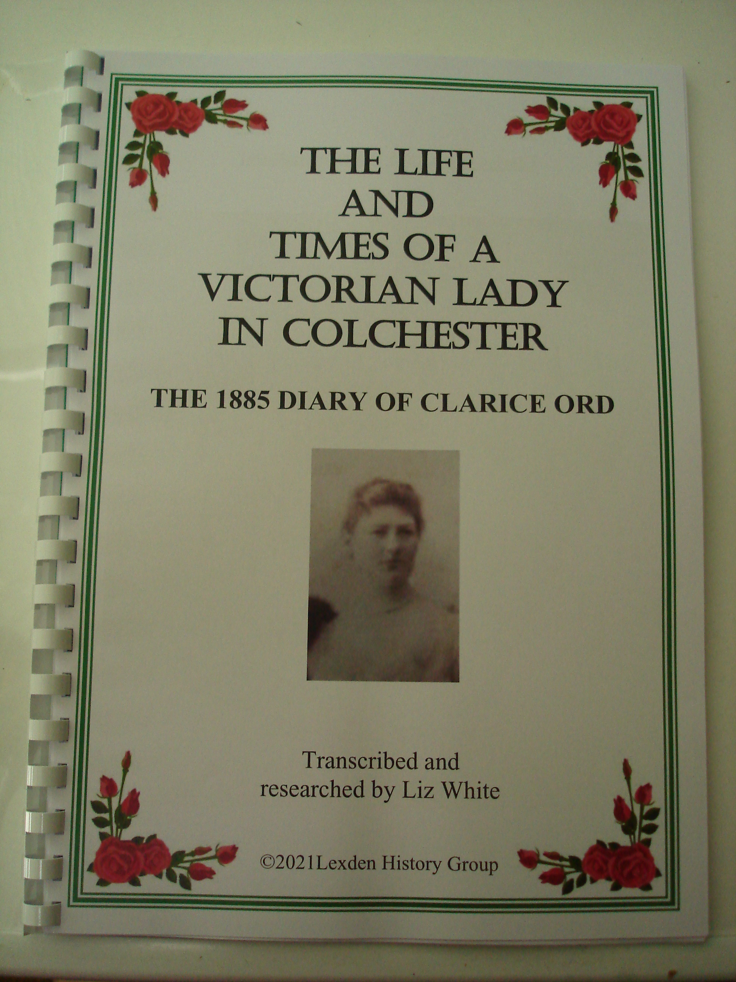Before finding a permanent Colchester based resting place, the diary was discovered on the mantelpiece at 136 Lexden Road (originally Lexden Manor), by Victoria Morley, having moved into the property in December 2020. Mrs Morley passed the diary to her mother, Alex Scott, who gave it to Sonia “Who would know what to do with it.” Sonia, immediately contacted Liz White, whose bloodhound instincts were quickly aroused - she can sniff out a promising story from a mile away! Liz wasted no time in starting her in–depth and time consuming research into the 220 names of friend, relatives, contacts and callers mentioned in the diary, to help piece together the amazing story in the life of Clarice Ord. Every one of the 69 pages contains fascinating information.

Copies of the book (left) are now available at a very reasonable £7.50. Please ask Liz or any committee member if you would like a copy. A very good Christmas present indeed!

Afternoon Meetings. With Christmas and the New Year rapidly approaching, we hopefully look forward to saying goodbye to Covid problems, and to the return of some sort of normality in our daily lives. One of which is the regular monthly meeting of the Lexden History Group.

One important, and we hope welcome and helpful change, is that from Wednesday the 12th January 2022, we shall continue our meetings at St Leonard’s Church Hall, but starting at 2.30 pm in the afternoon, rather than at 7.45 in the evening.

The recent request for members to express an opinion, showed an overwhelming majority voting in favour of the afternoon option. A small number of still working members (very few) and those who have current Wednesday afternoon commitments will naturally be disappointed. However, the LHG committee firmly believe that the change will be beneficial to the vast majority of members (no coming out in cold, dark and wet winter evenings). Hopefully, the time change will encourage the recruitment of new members, helping to increase our membership figures, and ensuring the long term viability of the Lexden History Group.

Our first afternoon meeting in January will be the Geoff Pettit Memorial lecture, with our own Liz White talking about the History of Education in Lexden. Looking forward to seeing you all on the 12th January at 2.30 pm.

Wishing you all a very Merry Christmas and most importantly a Healthy New Year.
Tales from the Churchyard - Charlotte Dalby, The Crown Inn

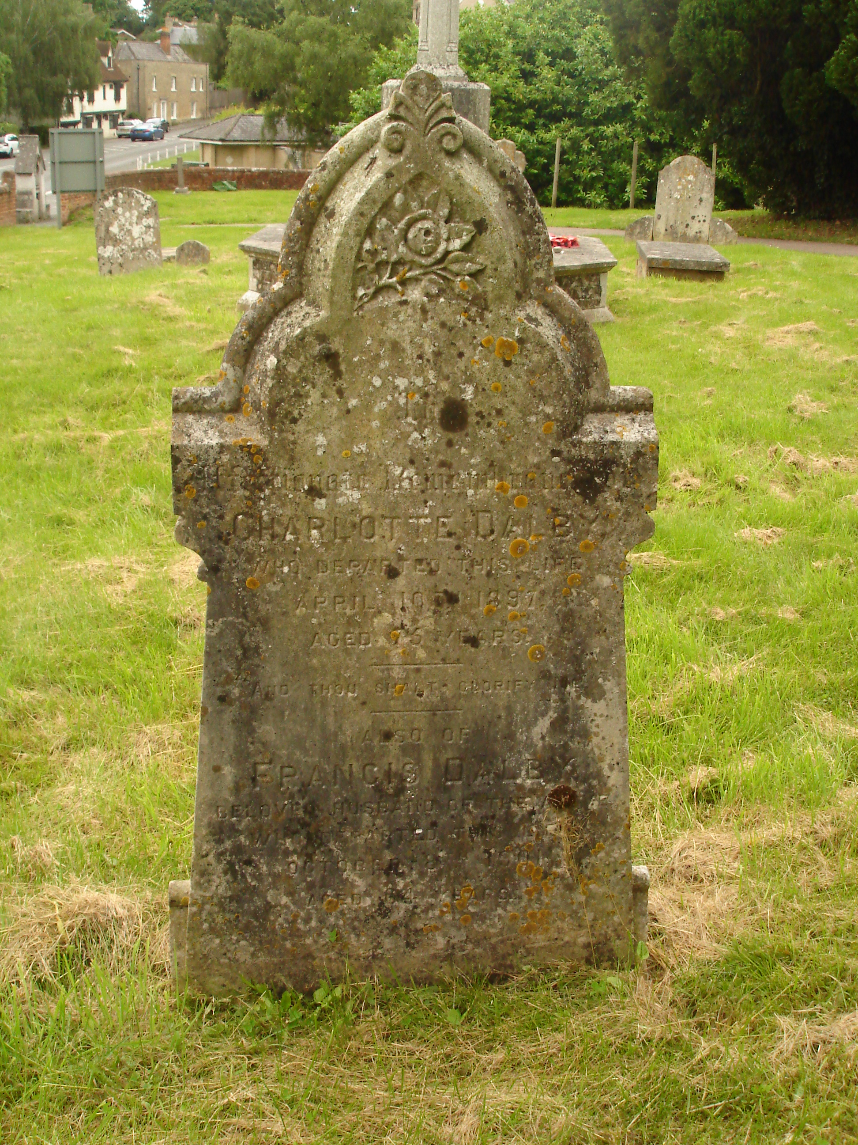To the left of the upper path from Lexden Road to the church is an ornate gravestone with flower engraving (right). It reads “In affectionate remembrance of Charlotte Dalby who departed this life April 10th 1897 aged 75 years. ‘And thou shalt glorify me.’ Also of Francis Dalby beloved husband of the above who departed this life October 8th 1901 aged 64 years”.

Hidden for years under the laurel is another grave: “In memory of Samuel Miller Taylor who departed this life November 13th 1868 aged 49 years. ‘The Lord gave and the Lord hath taken away. Blessed be the name of the Lord’, ... also of John Lawrence who died Novr 30th 1859 aged 30 years. Also in front of this stone are interred the remains of James Barker who died Novr 16th 1870 aged 34 years”.

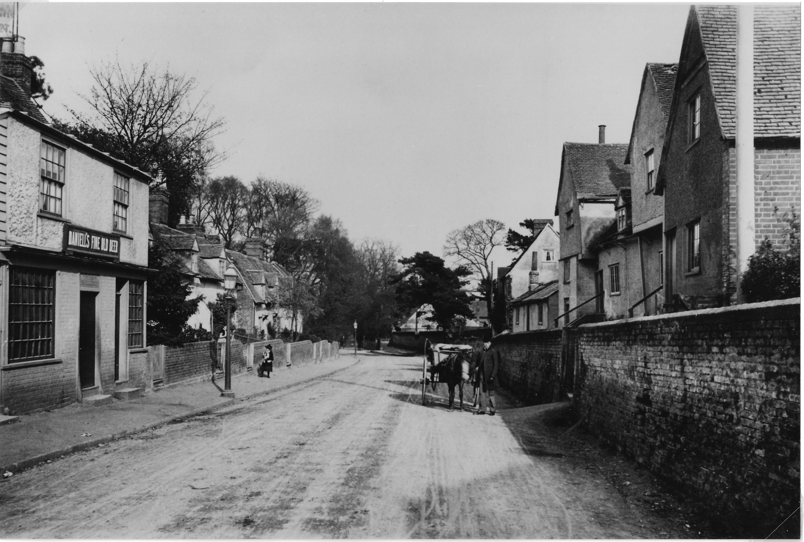Nothing indicates that the families on these gravestones are closely connected, but they are. Both Francis Dalby and Samuel Taylor were landlords of the Crown Inn in Lexden (left - pre 1900) but what is not obvious is that the same woman married both of them! She was Charlotte (née Lawrence) but her recorded birth date varied from 1817 to 1830. Census details give differing dates and even the inscription on the gravestone does not clarify the matter but with all the discrepancies regarding her birth date her place of birth remains constant - Belchamp Walter near Sudbury. Census details rely on the information given by the person interviewed and it appears that Charlotte was very flexible with dates! Interestingly there is a baptismal record for Charlotte Lawrence at St Mary the Virgin Church in Belchamp Walter dated 28th December 1817 and her parents are recorded as Sarah and Joseph, an agricultural labourer. In 1841 Charlotte was a female servant in Puttick End (now Puttock End) in Belchamp Walter, her age given as 22 years. Close by are her father and her two brothers, John and Robert, both aged 15. There is no record of a marriage of Charlotte Lawrence to Samuel Taylor, but one recorded on 11th February 1844 at Lexden, gave the bride’s name as Charlotte Farrow. Was this a genuine error on the part of the cleric or was Charlotte weaving her own truth? By 1851 Charlotte and Samuel Taylor were living at 3 Bacon (Beacon?) End, Stanway, with her two brothers, their ages given as 30 and 28, and who worked as agricultural labourers. Samuel was recorded as a Gravel Merchant, possibly working at the small pit at King Cole’s Kitchen which was operating at the time.

John Lawrence, aged 30 years, was buried in front of the grave of Samuel Taylor in 1859 and mentioned on the headstone. However no definite record of death can be found. It is probable that this man was Charlotte’s brother but the dates are again confusing as he was born in 1821 not 1829. It could suggest that Charlotte had great difficulty with dates!

The Crown Inn at 51 Lexden Street (now 235 Lexden Road) opened as a beerhouse
Tales from the Churchyard - Charlotte Dalby - continued

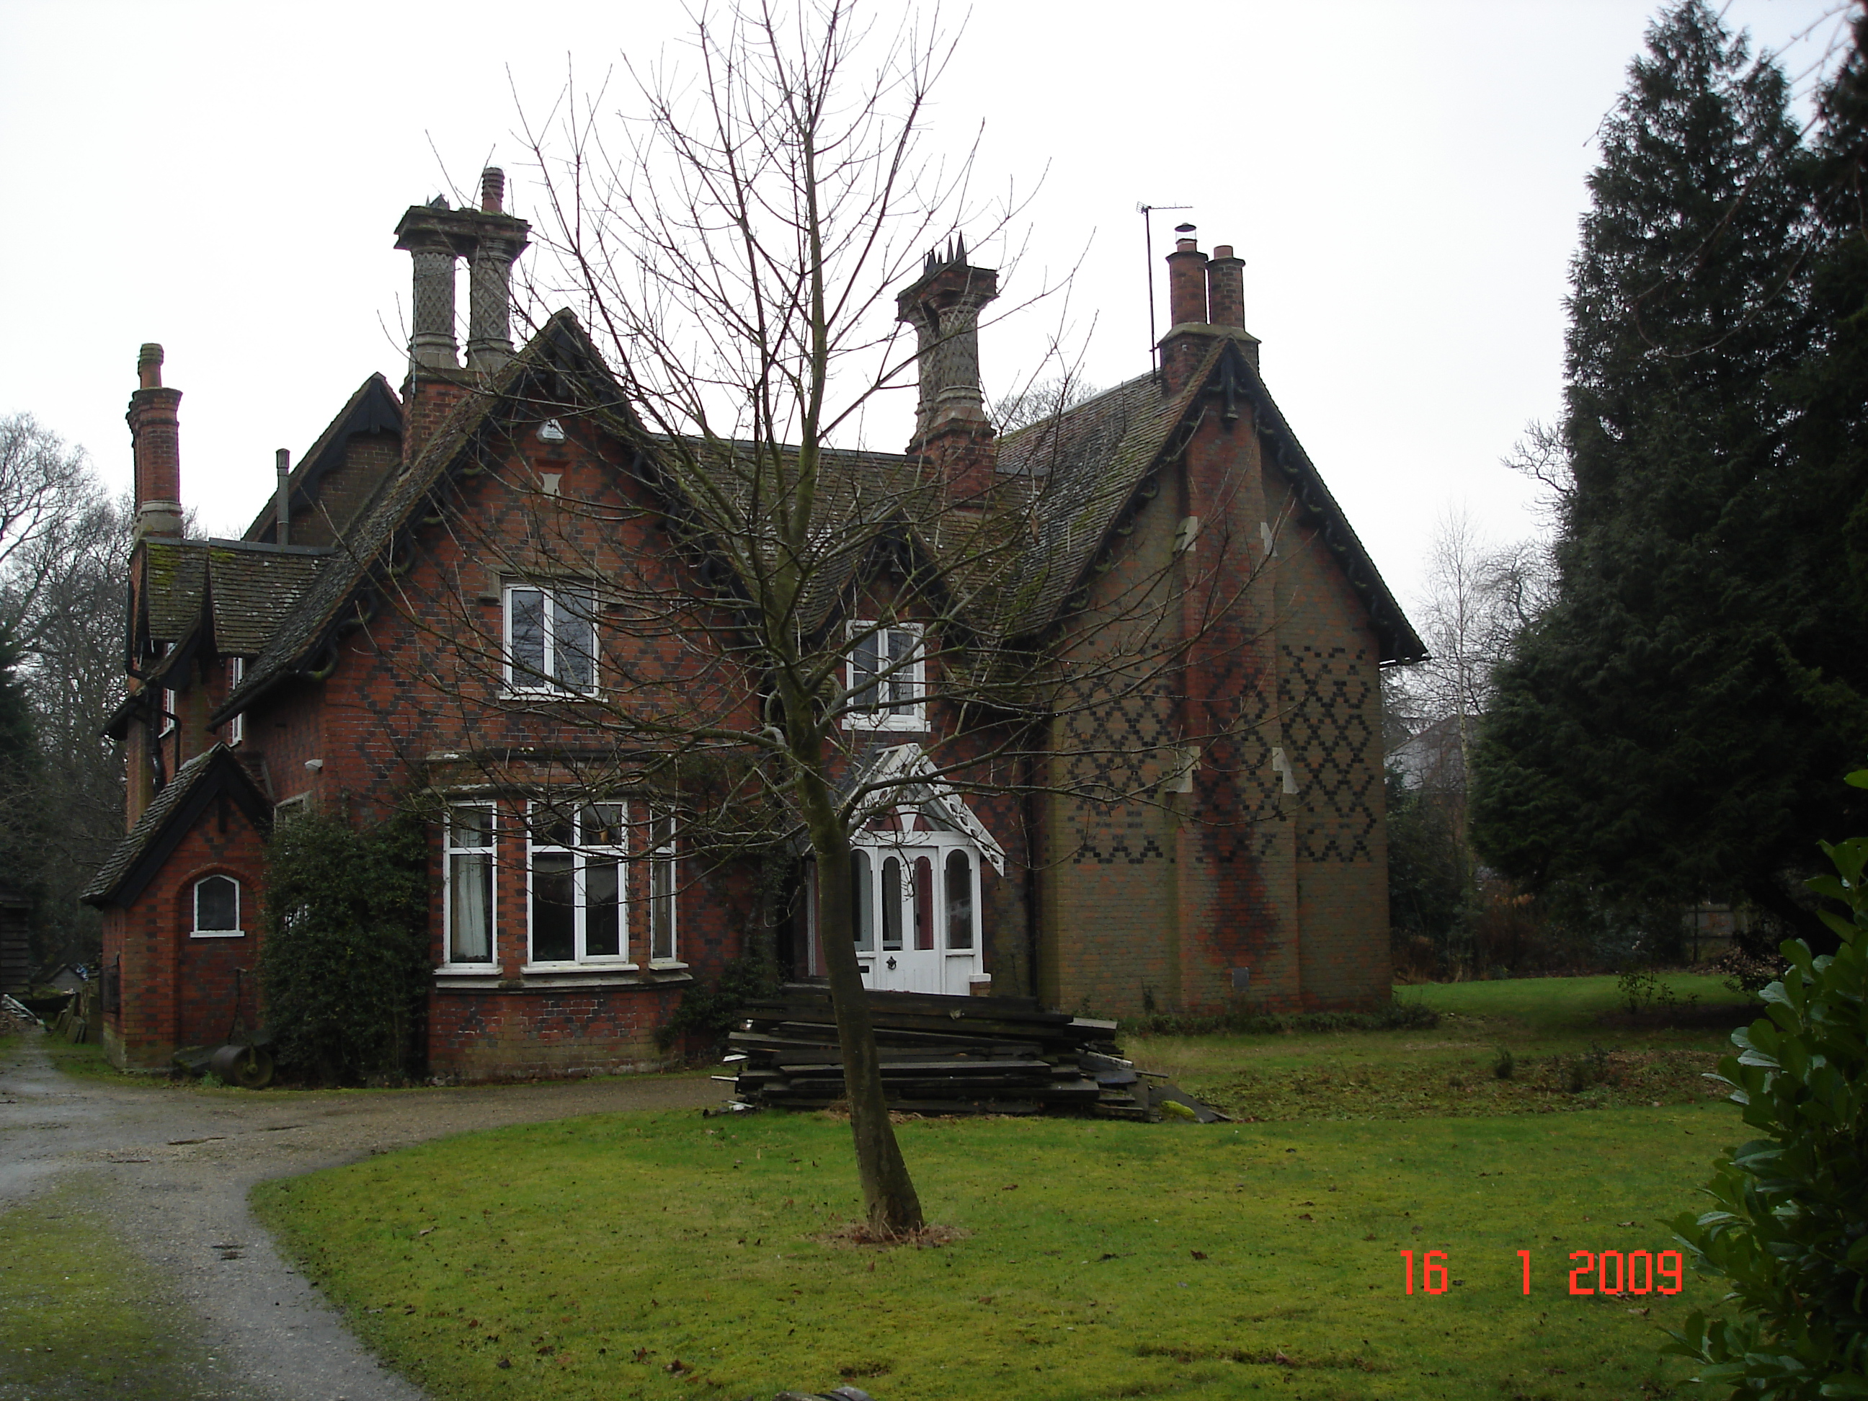 in about 1851 and by 1861 Samuel Taylor was recorded as the innkeeper with his wife, Charlotte, their ages given as 31 years. This would make their years of birth 1830! However, Samuel was born in Stanway in 1821, which approximates with the date on his gravestone. The Crown was also a Lodging House recorded in the Essex Standard of 1857 when Samuel travelled to Ipswich with Police Sgt Smith to locate a German who had failed to pay his rent at the Crown and had stolen clothing from his German colleague. Samuel’s actions and evidence were instrumental in getting one month’s hard labour for the offender. Meanwhile Charlotte’s brother, Robert, was married with four children, working as a carter and also running the Dog and Pheasant Beer House in Lexden Heath (now Heath Lodge in Heath Road - right). He probably learnt the trade from Samuel but soon returned to his main occupation of carter.

Samuel died in 1868 and a marriage between Charlotte Taylor and James Barker is recorded in the autumn of 1869. There was a large age gap but all Charlotte’s husbands were younger than she was. Little is known about James Barker, but he could have been the son of a local couple, Hannah and James, an agricultural labourer, who lived in Lexden Street. James junior died a year later in 1870 aged 34 and is included on the gravestone of Samuel Taylor. In the Census of 1871, the keeper of the Crown Beer House is Charlotte Parker, probably a mistake by the enumerator, a widow aged 46 years, so her birth year is now recorded as 1825! Emily Lawrence was living with her and working as a dressmaker. Emily, the daughter of Charlotte’s brother James and his wife, Hannah, was born in 1853 and in the Census is recorded as 18 years old. Ten years later she is 23 and in 1891 is 30!

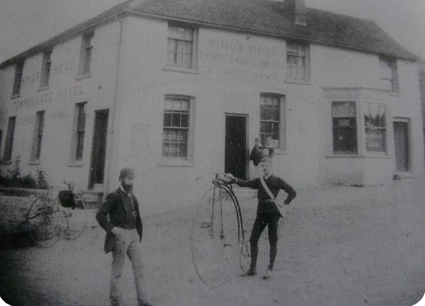What were the inns like at the time of Charlotte Dalby? It seems that even quite small pubs had several rooms and bars to accommodate different customers. Many had bars decorated with tiles, mirrors or mahogany panelling. Customers stood at the bar or sat on stools which, as did the chairs at tables, had either leather or dark red velvet seats which hid any spillage stains. Beer was the most popular drink but “The spectre of the drunkard” influenced many and encouraged the Temperance movement. In fact, there was a Temperance Hotel, the King’s Arms, (left) opposite the Crown!

In the 1860s the ‘drink question’ was high on the different political agendas and drunkenness was considered not only a cause of social problems, but also a medical problem not to mention a moral failing. Concern about this led the political desire to reform the licensing system in Britain. The Liberal Party generally supported the temperance movement seeking radical changes to the licensing laws but the Conservative Party wanted to protect the rights of those in the trade whether producers, retailers or consumers. Tighter alcohol regulations were imposed by the 1869 and 1872 Licensing Acts, which increased opposition to the legislation and defended the right
Tales from the Churchyard - Charlotte Dalby - continued

to buy and consume alcohol. In 1884 the British Society for the Study of Inebriety was created by a group of politicians and doctors demanding to detain and treat “inebriates”, leading to the Inebriates Act of 1898. The 1904 Licensing Act enabled magistrates to remove an existing licence if the landlord did not keep a well-ordered pub. However, research has found that in Victorian times, as today, most people drank for leisure with family or friends and it was only the minority that were reported as drunk. This suggests that people and politicians have not changed!

With Charlotte’s third marriage on 17th June 1878 at Lexden Church to (Jonathan) Francis Dalby, her father’s name of Joseph and occupation as agricultural labourer, are confirmed. Francis Dalby probably became the “Beer House Keeper” of the Crown Inn on marrying Charlotte. He was born in February 1837 in Westerfield, Suffolk, the oldest of five children of a coal metre or meter, an assessor of the weight or volume of coal, at Ipswich docks. Francis originally worked as a carpenter/joiner and lived in Ipswich with his first wife, Elizabeth, two daughters, Elizabeth and Louisa, and their son, Frank, until his wife’s death in about 1868. Francis had been accepted into the Freemason Lodge in Ipswich in May 1866 with his profession recorded as a builder. It would appear that he had moved to Colchester sometime during the 1870s as Frank’s death is recorded in Colchester in1879.

In the Census of 1881 Francis was recorded as a Beerhouse Keeper and joiner, with Charlotte (now aged 49), also a Beerhouse Keeper. Her niece, Emily, and his younger daughter, Louisa, aged 15, were “assistants at beerhouse”. Francis’s older daughter, Elizabeth, remained in Ipswich working as a dressmaker, and later as a housemaid at the Rectory in Creeting St Peter before her marriage in 1904.

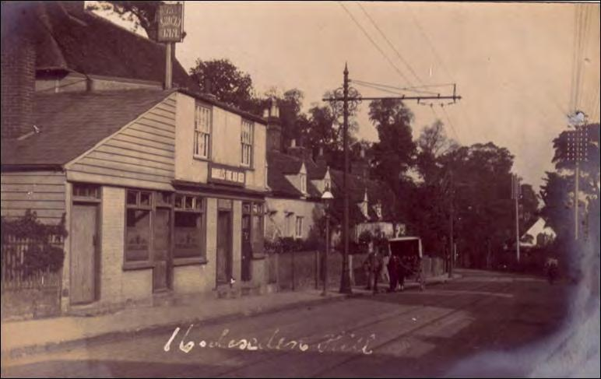Kelly’s Directory from 1882 records Francis as a Beer Retailer and in the 1891 Census he is at the Crown Beer Shop with Charlotte, now apparently aged 63, with Emily Lawrence as a Barmaid. It is interesting to note that although Charlotte seems unaware of her correct age, Francis’s date of birth doesn’t vary! After Charlotte’s death in 1897 he remained at the Crown with Emily as his Manageress. Kelly’s Directory records Francis Dalby as Beerhouse Keeper in 1902 but it would probably have been printed before his death in October 1901. Emily Lawrence then moved to Millwall in London where she was housekeeper to an elderly man. She is recorded as “widowed” although her name did not change. Perhaps marriage was a requirement of employment. She died in 1915.

Left - the Crown c1915 - note Tram lines and overhead cables

By 1911 John Vince, 63, was the beerhouse keeper at the Crown with Ernest, his son, assisting. They were familiar with the trade as they had both had been wine merchants’ cellarmen. Over the years the Crown changed hands and more recently it has become a restaurant, rather than an inn. No doubt many have spent happy times there and will continue to do so. Is Charlotte looking down on us all?
1960 The Dine In and Eat Out - Sonia Lewis

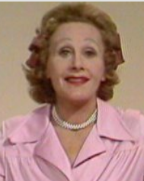When I starting researching I found the 60s morphed into the 70s and then the 50s came to mind, like dancing little imps. The 60s were the start of Dining In and Eating Out. I have looked on Google and my recipes are not the same as recorded, ie, Salmon Mousse - use a large tin of pink salmon, add tomato sauce which will enhance the colour and the flavour (no way) also Quiche which would, in my opinion, never be served as a main course.

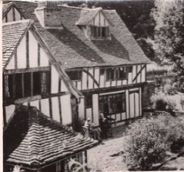A couple in our group ran a small holding and butcher’s shop at Great Bromley. Fanny Craddock (right), who lived in the area, would visit their shop. I believe she was not a pleasant person but she knew her cuts of meat. At the time, Esther Rantzen had a TV programme, “The Big Time”, with a competition for amateur cooks to design and cook a meal for celebrities. In one very famous programme in November 1976, a farmer’s wife from Devon cooked a meal for Ted Heath. Fanny Cradock was so rude during the programme, in fact she did the gesture of putting two fingers down her throat. The dear lady concerned was Gwen Troake, who was so nice, and Fanny Craddock so dreadful. I saw that programme and I am pleased to say Fanny Craddock never worked for the BBC again. Speaking about the incident in 1999, Esther Rantzen described Craddock as "hell on wheels", and that she had "reduced this poor little lady to nothing”.

Dining out was mainly at the Swan in Lavenham, The Bull at Long Melford, The Red Lion in Woodbridge and also Hintleshall Hall - all in Suffolk. Hintlesham Hall was owned by Robert Carrier, a well-known TV chef and author of cookery books. In Essex it was the Talbooth at Dedham (left) which was the most popular.

The menu at these places was very much the same, ie,
Starter - Soup of the Day, Prawn Cocktail, Grapefruit dishes, Melon Boat with ginger, paté with Melba toast, Potted Stilton with crushed toasted nuts and hot toast.

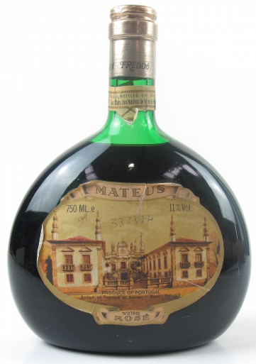Mains - Duck à l’Orange, Steak Diane cooked at the table, gammon steak with pineapple, Chicken Maryland, Beef Wellington. Steak dishes had a side salad and French fried potatoes, ie, chips!

Vegetables - Croquette potatoes, florets of purple sprouting broccoli, parsnips glazed in honey.

Dessert - Black Forest Gateau, Crèpes Suzette cooked at the table, half a pineapple, triple icecream, Brandy Alexander, Cassis Delice, American cooked cheesecake.

Wine - Blue Nunn, Mateus Rosé (right), Chianti, Muscatel, Chateau Neuf du Pape, treat time was Asti Spumante Fontana.

Facilities - cloakrooms were very basic and personal needs were not considered. Wipes, tissues, toiletries, etc, did not exist. The room contained toilets, wash basins, a bar of soap and a pull-down roller towel fixed to the wall.

Twice the Lavenham Swan management told us on arrival that a member of the Rolling Stones was in and I said “So what?” We had the pleasure of a Rolling Stone and his party at the next table. He was thin, scruffy and spread his legs across the aisle so that the staff had to step over him. I think it is fair to say that people
1960 The Dine In and Eat Out - continued

dining at the Swan were not fans of the Stones!

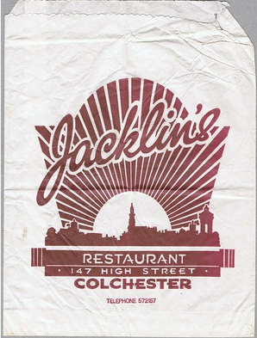In 1960 it was the start of clubs and food served would not be at a table on a plate. It would be Chicken, Scampi, cod bites and chips, all served on a square of rustic fabric in a basket. In the Colchester/Clacton area I recall the first large club was opened during summer time at Point Clear and people would queue from St Osyth to get on to the Point Clear Road. Butlins at Clacton extended club membership to local residents and we would attend the disco evenings. The swimming pool was situated between floors and as the sides formed a glass wall alongside the restaurant we could watch the swimming. Food was the usual baskets and chips with everything.

My memory goes back to the 1950s when the Young Farmers would meet at Jacklin’s in the High Street, Colchester. I did not attend for long as I was such a snob or prig in those days. Yes, I was! I own up that I wanted to talk milk yields, potato harvest, sugar beet permits and the cost of wellies, not play games with the boys. In those days marriages were made in Jacklin’s and what a blessing that was - like-minded people meeting and planning a future.

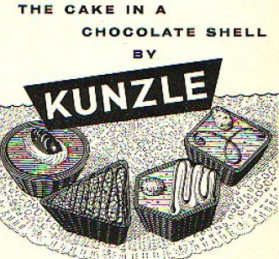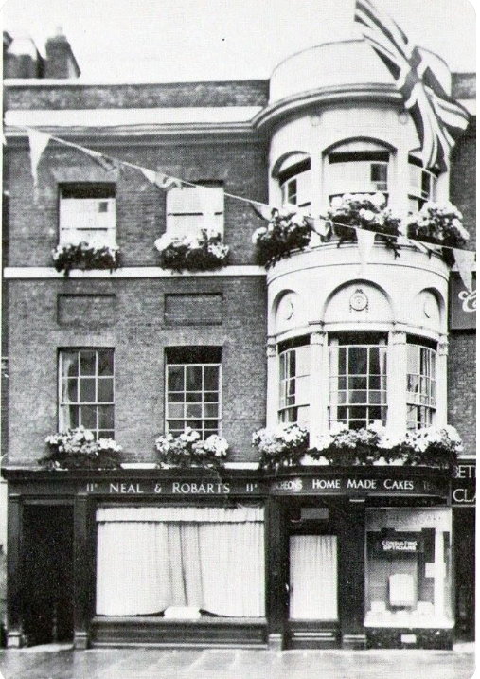Dances and Dinners were held at Nuttall’s (Wrights) Oak Hall with an entrance in Culver Street. Formal events were held at the George and the Red Lion and both hotels had large ballrooms. The first coffee bar was opened in a cellar situated in front of Neal and Robarts pastry shop (right) in the High Street. The hatch in the pavement was lifted and we went down the steps leading to a modern area (known as the Bamboo) where we could chat and enjoy frothy coffee served in Pyrex cups. I assume ladies shopping would meet for coffee in Neal and Robarts, Jacklin’s and Gunton’s and there was plenty of choice at each venue. My Mother’s was Jacklin’s and Oh! how I wanted to go into Neal and Robarts as they served Kunzle cakes (left)! Each coffee room had its own clients, even the business men met for coffee in the venue of their choice and never the twain shall meet!

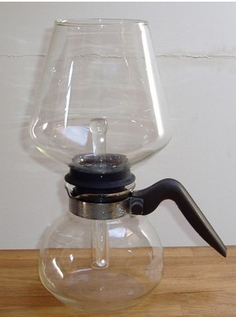Home Dining was a big event and in our circle I would say ten people sat round the table; farmers, builders, heating engineers and the families of our friends. We enjoyed the same wines and similar dishes to those in the restaurants but in larger portions. We did extra starters such as smoked haddock mousse, mini seafood pancakes in cheese sauce (now you would call them wraps). Our mains also included pheasant casseroled in Almanac and orange sauce, chicken hunter style, tagine of lamb, roast beef with all the trimmings. Other favourite desserts, some Cordon Bleu, were lemon mousse, Boodles Fool continental fruit flan and Cassis Delice, Brandy Alexander - my speciality. This was followed by cheese and biscuits with liqueurs. A favourite with the ladies was Tia Maria with double cream poured over the back of a spoon so it floated on top of the liqueur. We all had a Cona coffee maker (right).

1960 The Dine In and Eat Out - continued

The main course was set out in a hostess trolley ready to serve. The trick was to just parboil the green vegetables as they would continue cooking in the low heat.
The meal usually concluded with homemade petit fours, balls of coloured marzipan, fresh dates filled with cream cheese and ground almonds topped with toasted nuts, mini meringues coated with chocolate, strawberries and grapes. A childish favourite was Rice Krispy gooh. It was marsh mallow, toffee, butter and rice krispies. The top treat was Florentines and always the first mini mince pies. Pre-dinner drinks would be gin and tonic, whiskey, Martini and lemonade, Babycham, Snowball and Pimms, but not wine. There was beer for the men.

The dining out treat in the summer was the journey home in the moonlight from Suffolk particularly the full moon at Harvest time, seeing all the harvest in and smelling the earth.

Dresses - all the ladies had at least one Laura Ashley dress (left). I purchased mine in Cornwall and it took time for them to reach Colchester. Men wore flared trousers, shirts with big collars and kipper ties. One night a chap threw his car keys on the floor of my sitting room, I threw them back but he was left off my guest list. He said it was a joke, but we did not laugh.

Going out - this was Speedway and stock car racing at Ipswich and, of course, point-to-points which were held at Mark Tey and Higham where well-known horses would take part in races in order to qualify for the Grand National. I know we saw Charlotte Brew who was the first woman to ride in the Grand National when her horse was Barony Fort which refused at the 27th fence. The course was round a large field and we would see the start, run across the field and watch the horses gallop down the straight then run back across the field for the finish and maybe, just maybe, back in time to collect our winnings. It was interesting to see the car boots open with the picnics displayed: out came tables and chairs, plenty of champagne and cut glass.

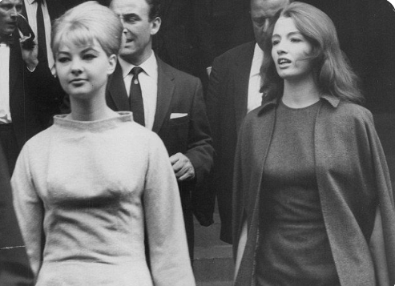My favourite for home dining which I did not list, as I was the only hostess to prepare it, was Beef Stifado - a rich Greek stew served with coleslaw and mashed potatoes. Dessert was pineapple slices set in a Kirsch sauce. The advantage of this dish was it was prepared the day before and left to improve with standing. I have looked at my earliest canapé book and it is dated 1988. We had nibbles - sausage rolls, sausages-on-sticks, cheese straws, prawn vol-au-vents, mixed nuts. Whatever - it would be jolly good.

I once held a fancy dress party. Some guests caused confusion when they went to the wrong house! Four of us went to one at Langham, the two men went as Mandy Rice Davis (right) and Christine Keeler (far right). They had hairdressers’ wigs on and were professionally made up. When they got out of the car, honestly, they were chatted up by two locals walking to the pub. I should point out there were no street lights. I went as Elvis but did not sing, but that was the end of fancy dress and we avoided Langham after that. We listened to the 1966 Cup Final when England won. One Saturday I was in the butcher’s shop at Elmstead a Ford car pulled up and a young handsome man got out, came into the shop and was recognised by a resident who
1960 The Dine in and Eat out - continued

spoke to him. It was Bobby Moore who explained he had drawn the short straw and had to do the shopping. He was on the way to Frinton for a holiday with his family. My grandson, a West Ham supporter, is proud to tell anyone who will listen that his grandma met Bobby Moore.

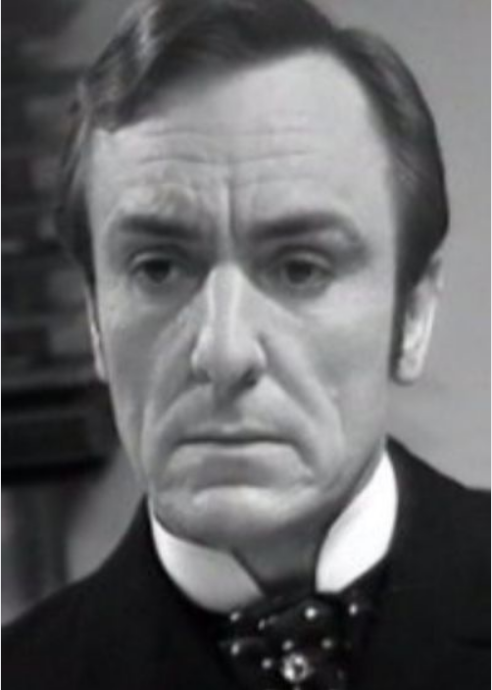We talked about TV programmes, mainly the Forsyte Saga which went out on Sunday nights. It was so popular some churches even altered the time of evensong. I think most of us had sympathy with Soames - the main character - played by Eric Porter (left), who supported the Colchester Rep many times. I did not see him but I did see Dora Bryan and Peggy Mount. It was reported that a letter arrived in England marked “Soames, c/o Colchester” and it reached Eric. These were good times, this was village life, and I end with a big thank you to the girls, yes - girls, who shared recipes and fun with me.

PS: I have many of the original recipes if anyone would like them so please contact me and I’m still trying to think of the red wine we drank - any suggestions welcome as it will sooth my memory! I also have a collection of old magazines.

Beware First Impressions - Derek Keeble

Beginning We, Jessie and I, knew from our early wedded days that we would indulge in wide outdoor games. When Jessie became emergency Honorary Secretary to Colchester Ramblers at the beginning of the seventies, we were developing beyond regular local walks. I did not share Jessie’s vision of Trails - published route aids being crucial - but I respected her enthusiasm and joined her force willingly, nay, eagerly.

Could we begin alone? “Yes alternative not known." Where were we to begin? “Keep the obvious county border mammoth trail on hold until we had gained some experience of the oeuvre.” So we settled for the Hadleigh-Hadleigh Way across the grain of East-flowing rivers between the Suffolk and Essex settlements of that name. It was soon explored and ready for exposure. Meanwhile, the route of my long-training run caught Jessie’s attention as a potential walk-trail. The Camuplodunum ensued falteringly through dubious home-publishing procedures of booklet making and sales. The Hadleigh-Hadleigh Way did not suit this treatment, and went on hold, until 1988, when as an freelance writer, I serialised it as a story of a barge-hand called Jonathon who fled from an altercation with his skipper at Leigh-on-Sea-juxta-Hadleigh in Essex, to Hadleigh in Suffolk en route to his home in Ipswich’s Dock environment.
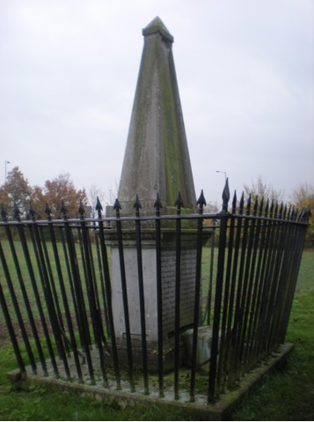
Middle 1987 Whilst exploring a route from Hadleigh to the Vale of Gipping for a riverside entry into central Ipswich, I espied a rough-hewn engraved stone on Aldham Common. “Rowland Taylor, burned at the stake here in 1555”. It grieved me; I found calm only after dismissing Rowland as a Suffolk yokel who got too excitedly vocal in a crowd assembled to watch macabre scenes, so the mob cast him ad hoc from their ranks to join the principals in the heated ghastly gestures in the name of Queen and God. A larger memorial (right) was erected in his memory in 1819.

Beware First Impressions - continued

End Circa 2011 I found myself in need of a comfort stop when travelling along the
M5. I have no love for Motorway Service Stations, but do have a National Trust membership card, so I popped into their Hanbury Park property for relaxing refreshment in the NT restaurant followed by a stretch of legs in an attractive Worcestershire parkland. I was lured into a red sandstone of parish church. Very interesting in several respects. I like statistical lists of parish incumbents. Hanbury St Mary the Virgin’s has one, spaced at one line per incumbency; with one exception. A priest called Revd. Dr. Rowland Taylor had two or three or lines of info. Strange a reverend doctor should have the same name and date as a Suffolk yokel.

Follow-up I sought his history. It was worth the bother of skipping back 460 years. He was the same Rowland. He hailed from Northumberland, not Suffolk. He was not a yokel, but a privileged scholar who graduated in Law at Cambridge University. He excelled in a career at Law. Then abruptly switched to a life in the Church, then transfiguring as a Protestant Church of England. He worked in Africa as a priest, won acclaim, and returned to England to frequent Westminster corridors and chambers deploying his legal skills as an advisor to King and Government during the politico-religious disruptions building towards our Civil War a few decades on.

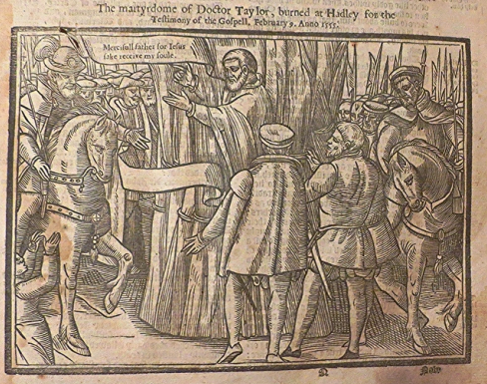Taylor’s church career brought him and his wife, Margaret, the daughter of William Tyndale, to Hadleigh in Suffolk. Supporters of our new Catholic monarch could not rest whilst he was abroad, so a plot to end his life hatched at Aldham Common. There probably was not a great crowd. He had been held captive in Lavenham, safely away from his popular support in Hadleigh, such was the plotting to end his influence. (left - woodcut from Foxe’s Book of Martyrs)

Rowland Taylor influenced powerful people and an exaggerated billing on Hanbury’s priestly record, and a rough hewn stone in an Aldham hedgerow seem inadequate, yet they have at least fed my admiration for his endeavour. I am empathetic for his widow. Her father was killed by the same burning process as part of the same christian skirmish, as her martyr husband. Tragic.

Footnote Since 1989 Jonathon’s Journey is a 73 mile Trail afoot across corduroy countryside formed by the Thames, Crouch, Chelmer, Brain, Blackwater, Colne, Stour, Box, Brett and Gipping rivers to Orwell Docks. (To be continued)

Royal Observer Corps at Lexden - Bernard Polley

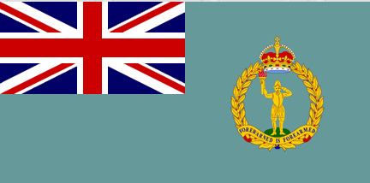Until 1995 a flag (right) was flown every day over the front door of 22 Lexden Road - it was the home of Colchester’s Royal Observer Corps. The Royal Observer Corps (ROC) was a civil defence organisation intended for the visual detection, identification, tracking and reporting of aircraft over Great Britain. It operated in the United Kingdom between 29th October 1925 and 31st December 1995 when the Corps’ civilian
Royal Observer Corps at Lexden - continued

volunteers were stood down (ROC headquarters staff at RAF Bentley Priory stood down on 31st March 1996).

A “Raid Reporting System” has been set up in 1925 to aid the provision of visual detection, identification, tracking and reporting aircraft movement over the country. This group was later known as the Observer Corps and was awarded the Royal title by King George VI in April 1941 as a result of their service during the Battle of Britain. From ROC HQ there were 25 Group Controls (Colchester was number 4) with 870 monitoring posts, underground bunkers, each covering the Group with information by tracking enemy infiltration. Some of the 36 posts near Colchester were located in places such as Braintree, Kelvedon, Tendring and Earls Colne.
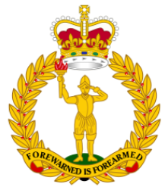
Composed mainly of civilian part-time volunteers, ROC personnel wore RAF style uniform and came under the administration control of RAF Strike Command and the operational control of the Home Office. (right - ROC Badge) Civilian volunteers were trained and administered by a small cadre of professional full-time officers under the control of the Commandant Royal Observer Corps, often a former serving RAF Air Commodore.

The Colchester Group was originally founded in 1926 as No 18 Group with an operational centre on the top floor over Robinson’s Chemist and Post Office at 124 High Street. Later it was relocated to the Corn Exchange further along High Street, and in about 1930 it moved again to the Telephone Exchange in West Stockwell Street until 1943 when Colchester’s ROC settled at the Victorian house called ‘Errington Lodge’ on the corner of Lexden Road and West Lodge Road. (George Henry Errington was High Steward of Colchester from 1860 to 1883 and lived at Lexden Park.) In 1953 the group was redesignated as 4 Group. Administrative duties were carried on at the house and in the garden a purpose-built underground defensive bunker was built where all aircraft movements were controlled. In his book ‘Essex at War’ Hervey Benham recorded what it may have been like in the bunker during the Second World War:

‘Few people were privileged to see this operations room, the nerve-centre of a great network of highly developed communications, was one of the most remarkable scenes in the whole local war effort. Around the table map sat a close circle of trained operators wearing telephone headphones and microphones As the information poured in from the 35 posts the small metal symbols moved steadily across the map, indicating by their colour and other code devices the type and number of aircraft represented, and whether friendly or hostile. On a wall map the situation in adjoining group areas was constantly to be seen, while from the gallery above more operators tensely looked down, reporting information from the map to other formations, centre and services. Under the brilliant artificial light the scene was somewhat reminiscent in its eager concentration of a crowd of gamblers around a table, though the bomb-proofed building with its miles of telephone wire and utilitarian efficiency was a background far removed from the opulent luxury of a casino - and the stakes were life and death.’

The outposts were manned 24/7 by two volunteers watching the skies for enemy aircraft and passing information back to group control. Tough work for the men, often middle-aged, who had been on duty all night, and having to return to their civilian jobs next morning.
Royal Observer Corps at Lexden - continued

After the war in the 1950s came the Cold War looming between the United States and Allies against the Soviet Union with the threat of a nuclear attack. In 1955 the Royal Observer Corps was given the added responsibility of monitoring possible nuclear bursts and fall-out. ROC was chosen for this new role as the infrastructure and lines of communication were already in place and the personnel involved were familiar with the use of monitoring equipment. Fortunately none of this preparation was necessary for the conflict eventually ended with the collapse of communism and the dissolution of the Warsaw Pact in 1990.

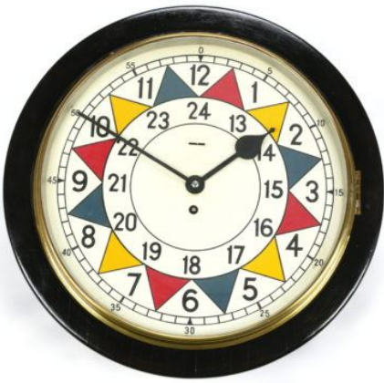This led to a government defence spending review resulting in the ROC’s monitoring posts and group control personnel being stood down on 30th September 1991. The bunker at Errington Lodge was no longer required so was demolished and redeveloped in 1995, and the house returned to private residential use.

As a footnote, the Royal Observer Corps sector clock (left), made by W Elliott Ltd, and situated in the Colchester operations room from 1941-1982, was presented to a former volunteer on his retirement. After his death the family put the clock up for auction and it was sold for £4,000.

Your Committee

Chairman
Stan Kordys 01206 502282
s.kordys@ntlworld.com

Vice Chairman Treasurer
Dick Barton 01206 573999 Melvin White 01206 575351
dickbartonlex@gmail.com melvin.s.white@btinternet.com

Secretary Membership Secretary
Jackie Bowis Liz White 01206 522713 Jackie Bowis 01206 561528 alangwhite187444@hotmail.com jebowis50@gmail.com

Magazine Joint Editors Archivist
Liz White / Jackie Bowis Bernard Polley 01206 572460
alangwhite187444@hotmail.com heath86end@aol.com

General Members Refreshments
Ian Bowis 01206 561528 Vacant
Sonia Lewis 01206 579950
sonialewis@waitrose.com

Meetings from January 2022 will be at 2.30pm

Our first afternoon meeting is on 12th January at 2.30 pm,
the Geoff Pettit Memorial lecture,
with our own Liz White talking about
The History of Education in Lexden.

Looking forward to seeing you all.

